WEB APP – EMPLOYEE MANAGEMENT SYSTEM
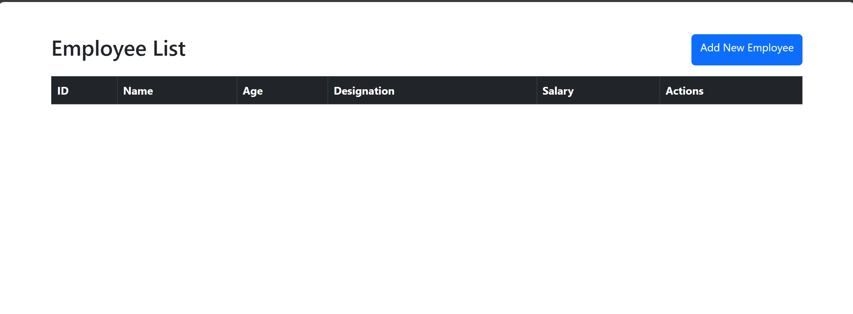

This screenshot shows the get method of the app, as there are currently no entries in the database, no values are being shown here.
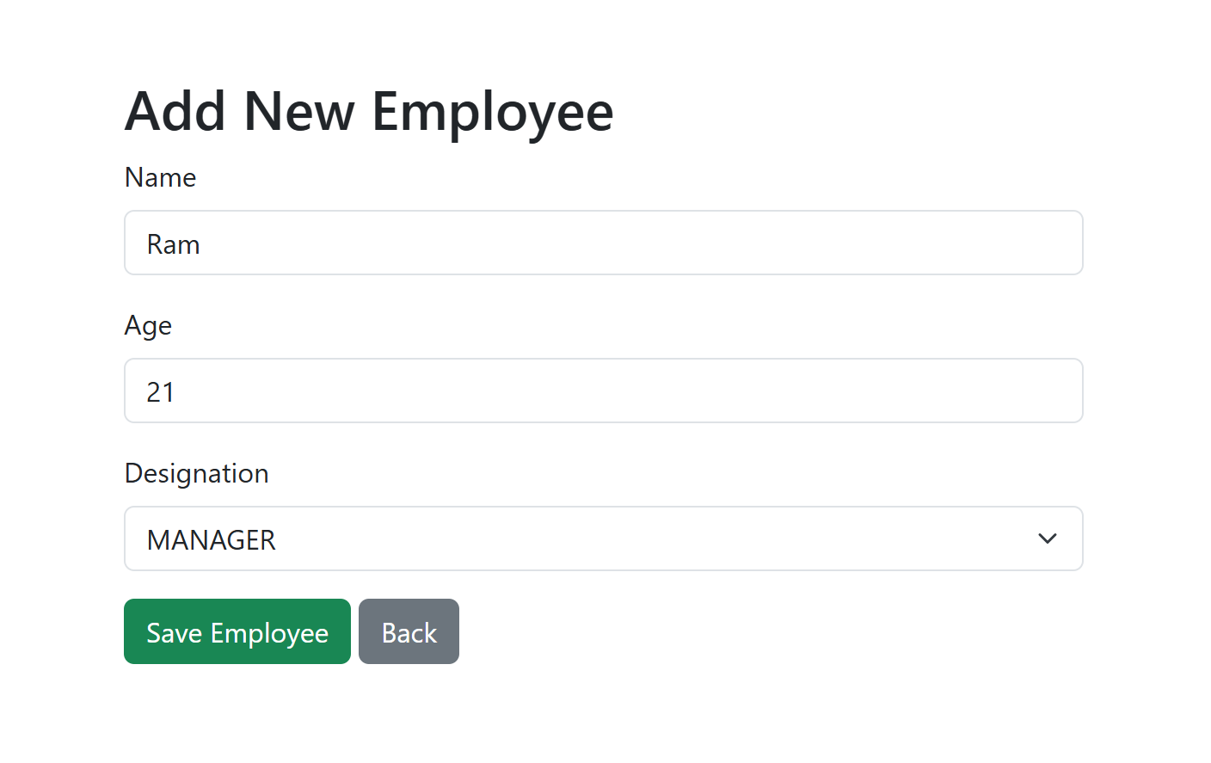
On clicking the add employee button, we are redirected to another page where a form is being displayed for us to enter the employee details, on submission of this form, a post request is sent to the backend to save the data

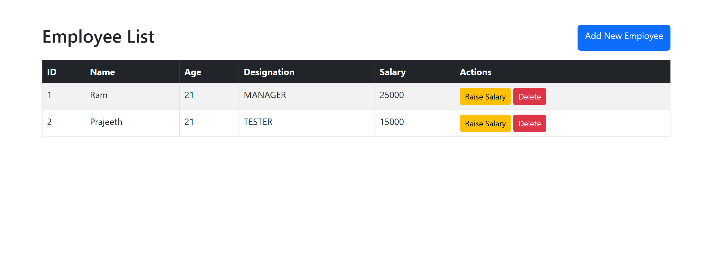

As you can see from this screenshot, two employees have been added and are now being displayed. In addition to this, two options are available to be performed on these employees; raise salary and delete.

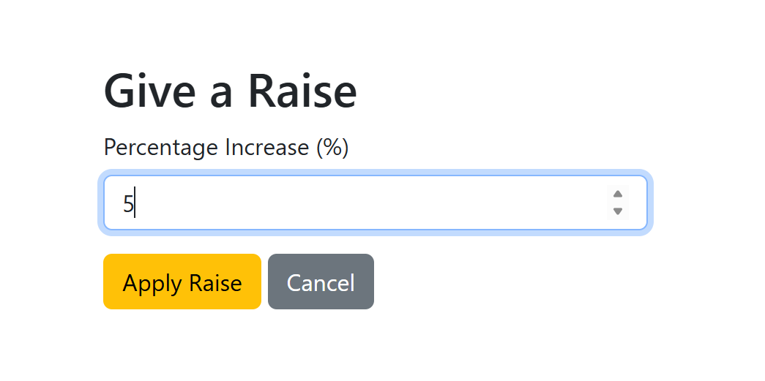

On clicking raise salary, you are taken to another form where you can specify the percentage to be raised.

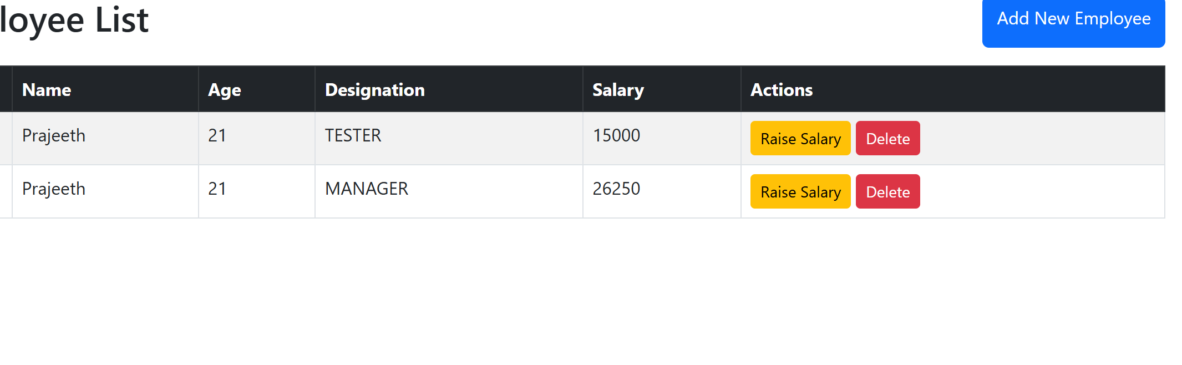
After raising the salary, the changes can be seen when using the get method on emplyees.
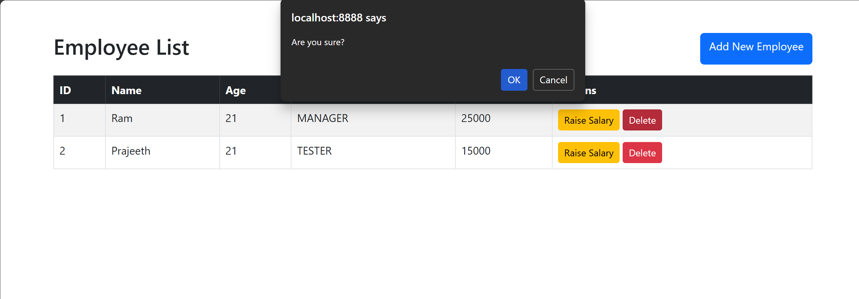

When clicking on the delete button, you get a warning. Proceeding further will result in the employee being deleted.

